**Data Visualisation Module**

**(CMP020L013S) - (PG)**

**Spring Term 2022-2023**

**Coursework 1**

**Student Name: Lashika Arunachalam**

**Student ID: ARU21537357**

***Task 1: PYTHON VISUALISATION***

**Visualisation 1:**

**What are the Covid cases in each Country?**

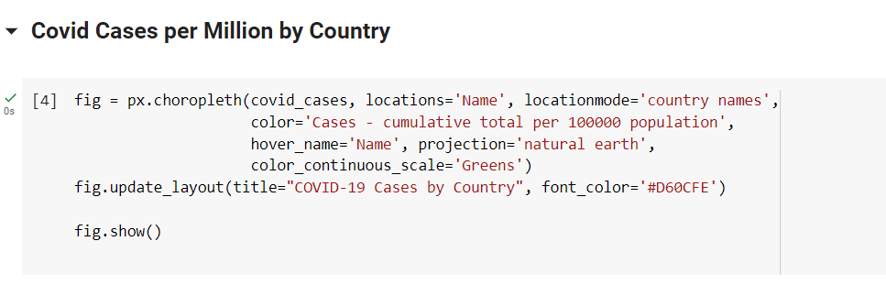

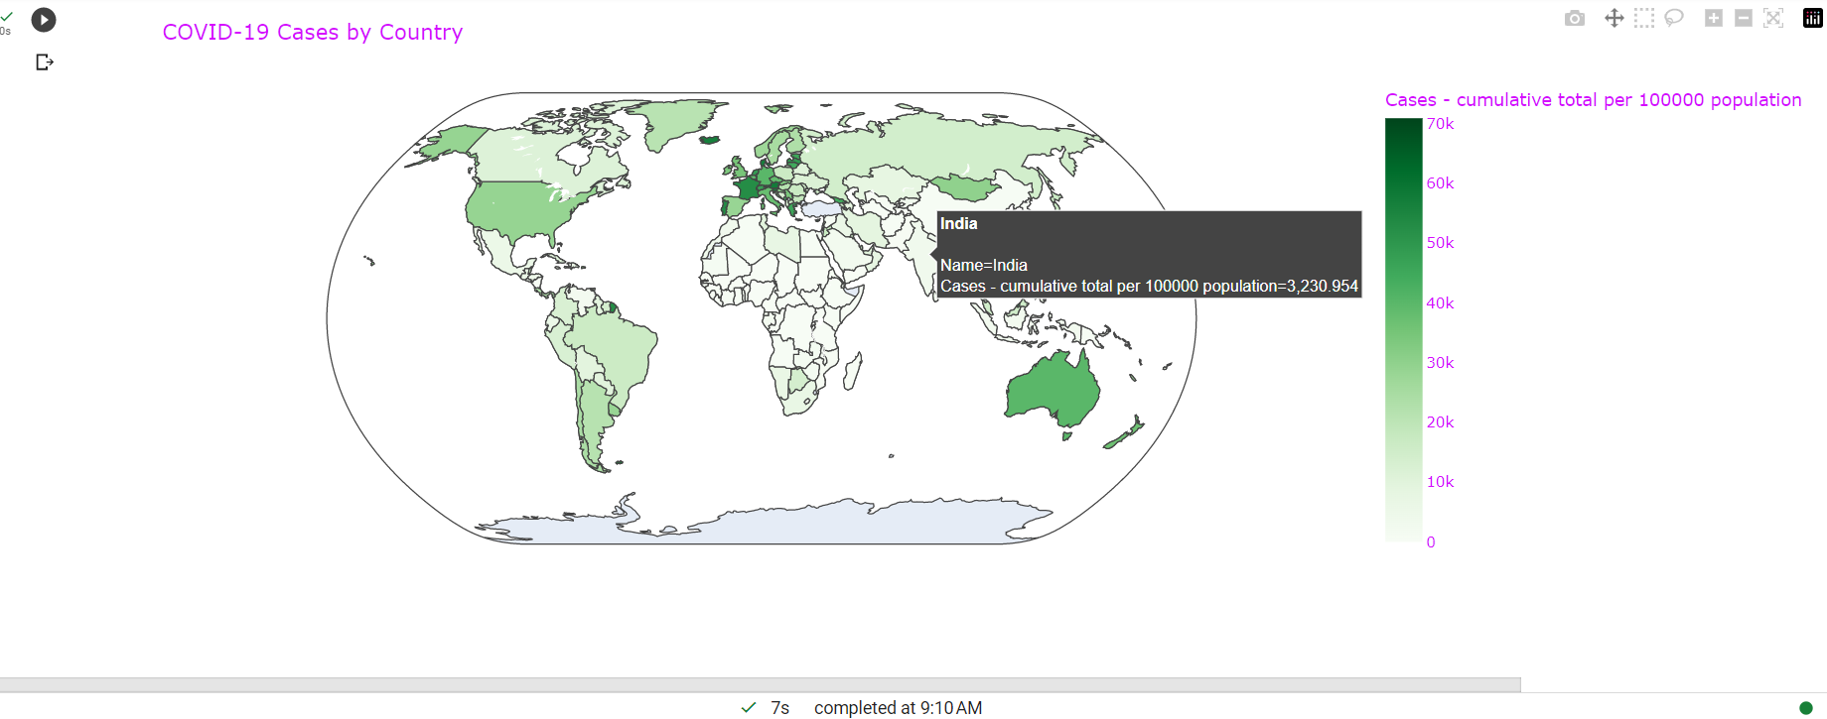

In order to offer a consistent measurement of the COVID-19 impact across nations while accounting for the number of citizen variations, cases per million are used as a statistic. As a result, analyses among nations may be made that are more significant because it is clearer how much of each country's people have been impacted by COVID-19. When analyzing the effect of COVID-19 in various nations, it's crucial to keep in mind that infection rates per million are only one of the several statistics that can be used. Additional aspects to take into account include testing capacity, healthcare resources, and public health initiatives.

**= = = = = = = = = = = = = = = = = = = = = = = = = = = = = = = = = = = =**

**Visualisation 2:**

**What are the Top 10 Countries which have Active Cases?**

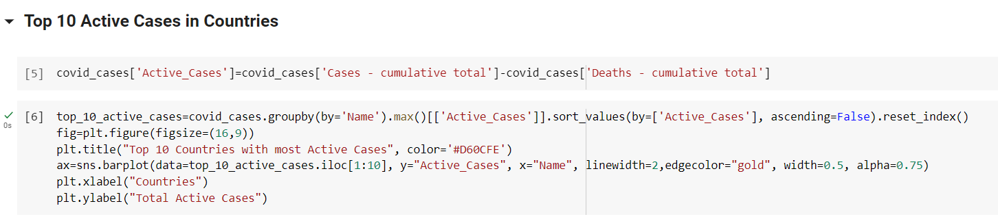

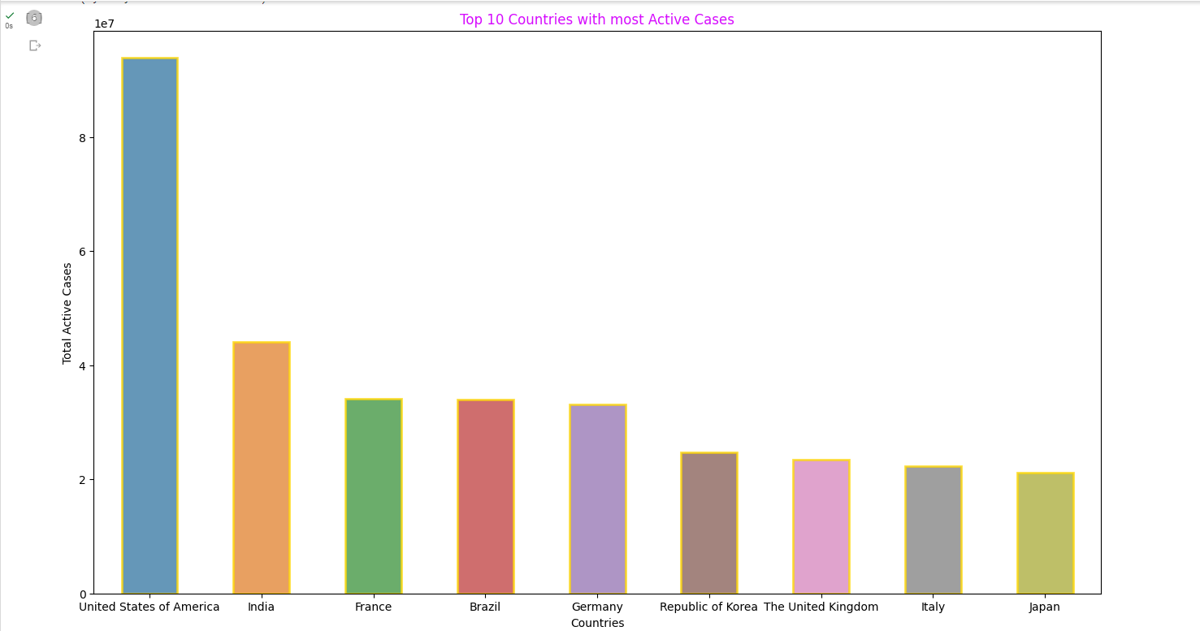

The top 10 nations where COVID-19 cases are currently present can offer crucial information about the outbreak's present state on a global scale. Making educated decisions on how to deploy supplies and implement the right measures to stop the propagation of the virus can aid healthcare professionals and lawmakers. Additionally, it might be beneficial for people to gain additional insight into the scenario at hand while performing the required safety procedures when they move or engage with peers.

**= = = = = = = = = = = = = = = = = = = = = = = = = = = = = = = = = = = =**

**Visualisation 3:**

**What are the Total cases over time?**

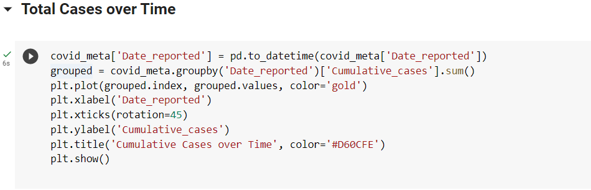

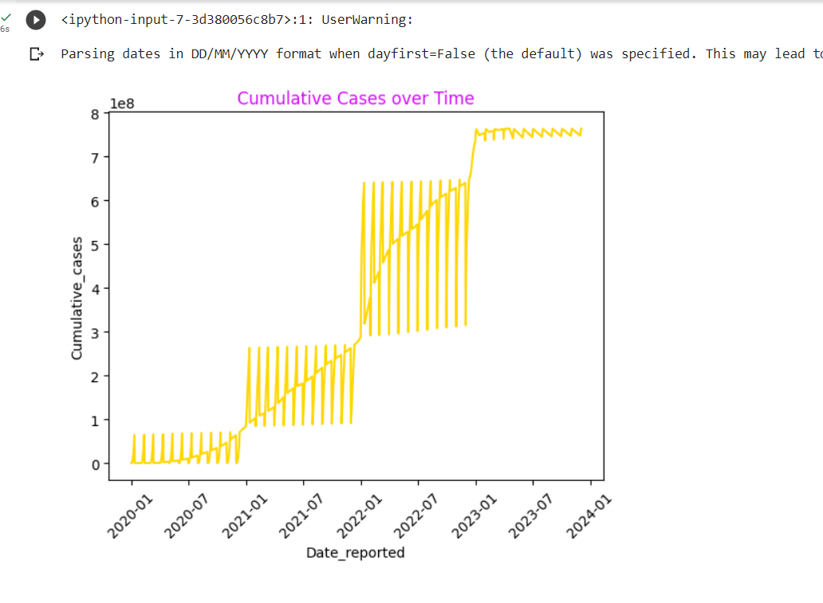

In COVID-19, the aggregate number of cases throughout time is significant since it enables us to comprehend how the illness is spreading and how it may do so in the future. They also assist us in comprehending the efficacy of interventions like immunization and social isolation in halting the virus's spreading. By keeping a record of the total cases over time, we can spot patterns and indicators that will allow us to deal with a global epidemic most effectively.

**= = = = = = = = = = = = = = = = = = = = = = = = = = = = = = = = = = = =**

**Visualisation 4:**

**What are the Covid Cases and Deaths per Million?**

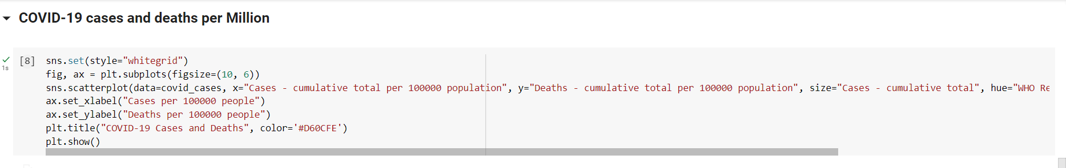

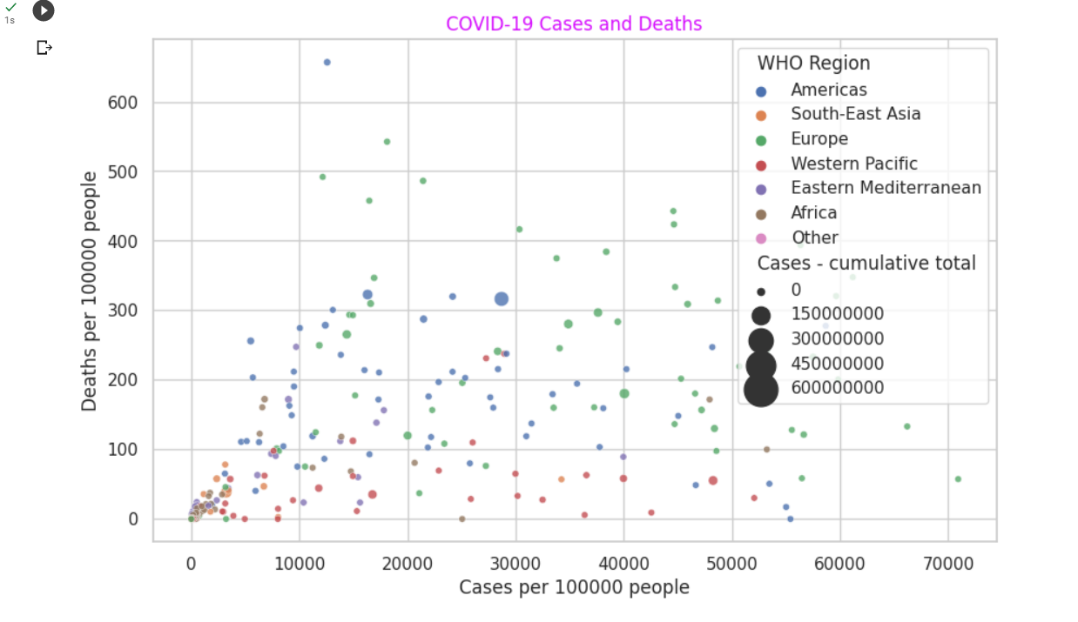

The causes of incidents and fatalities from COVID-19 per hundred million persons are complicated and multifaceted. The few of the elements that support the propagation of COVID-19 inadequate immunization, inability to receive medication, a weak healthcare system, a substantial number of people, limits on travel, and viruses in different forms.

**= = = = = = = = = = = = = = = = = = = = = = = = = = = = = = = = = = = =**

**Visualisation 5:**

**What is the Death Rate Region-wise?**

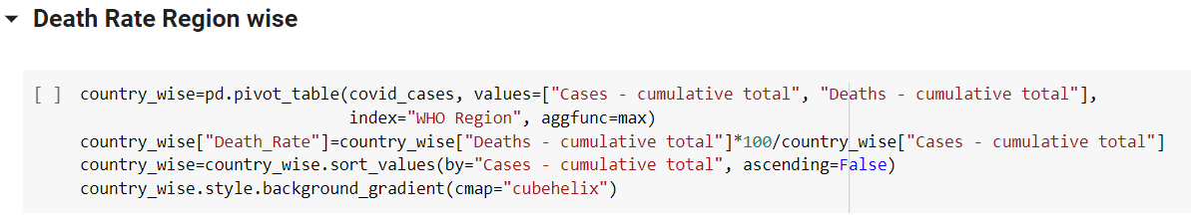

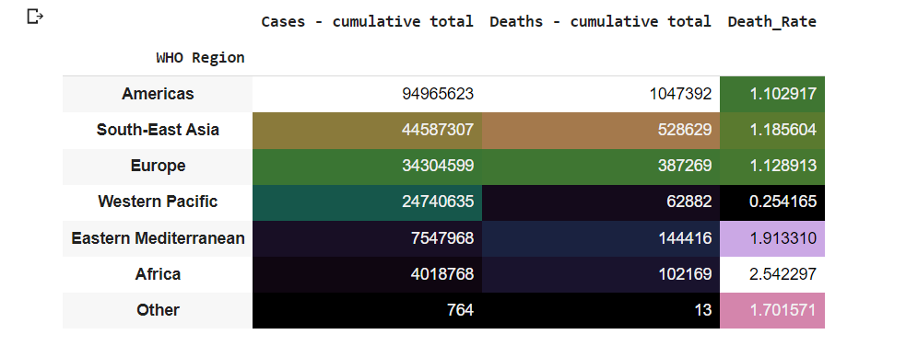

The regional variation in death rates is significant since it can reveal patterns and trends in how the COVID-19 pandemic is affecting various places. Healthcare providers and politicians can better evaluate the intensity of the pandemic in each place and distribute efforts correspondingly by examining mortality rates in multiple areas.

Furthermore, comparing mortality rates by location might help find biases and differences in how the epidemic is affecting various groups. For instance, if a specific ethnic group or region has much higher death rates than others, this may indicate that there are particular difficulties or restrictions for that population in obtaining therapy or adhering to wellness recommendations.

**= = = = = = = = = = = = = = = = = = = = = = = = = = = = = = = = = = = =**

**Visualisation 6:**

**What are the top countries with the highest number of deaths?**

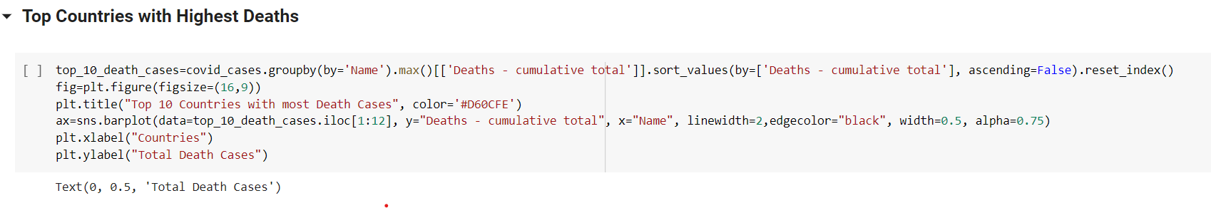

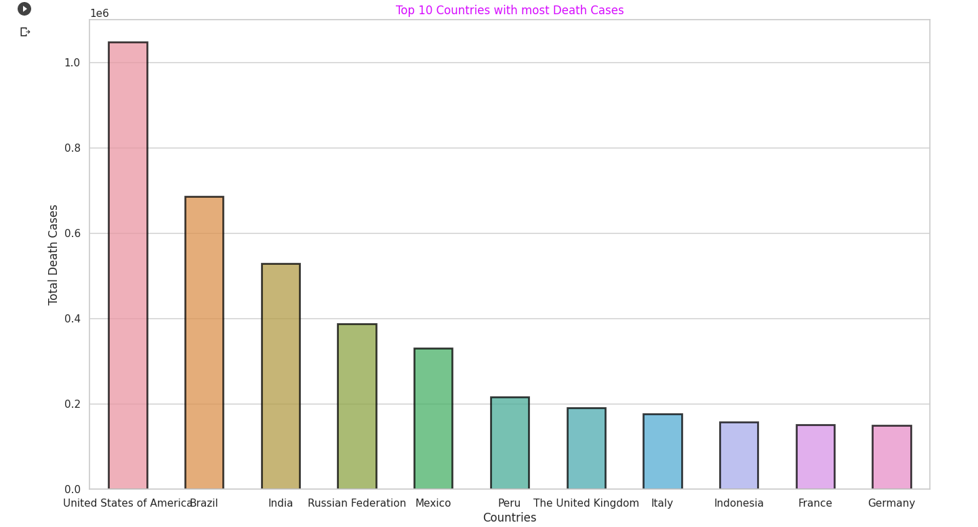

The greatest COVID-19-related mortality rates in the nations with the highest populations are caused by a variety of factors. All the overall number of deaths directly linked to COVID-19 and its indirect effects, such as the suspension of vital health care or transit difficulties, are taken into account. Increased mortality rates can also be caused by variables including population density, age distribution, underlying health issues, as well as accessibility to care.

**= = = = = = = = = = = = = = = = = = = = = = = = = = = = = = = = = = = =**

**Visualisation 7:**

**What are the Total Death counts in each country?**

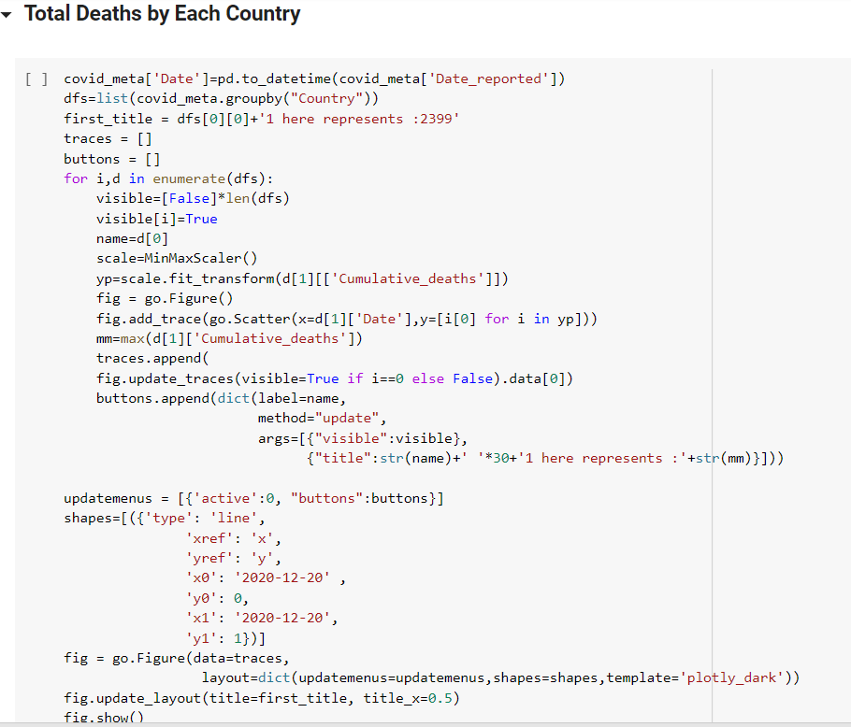

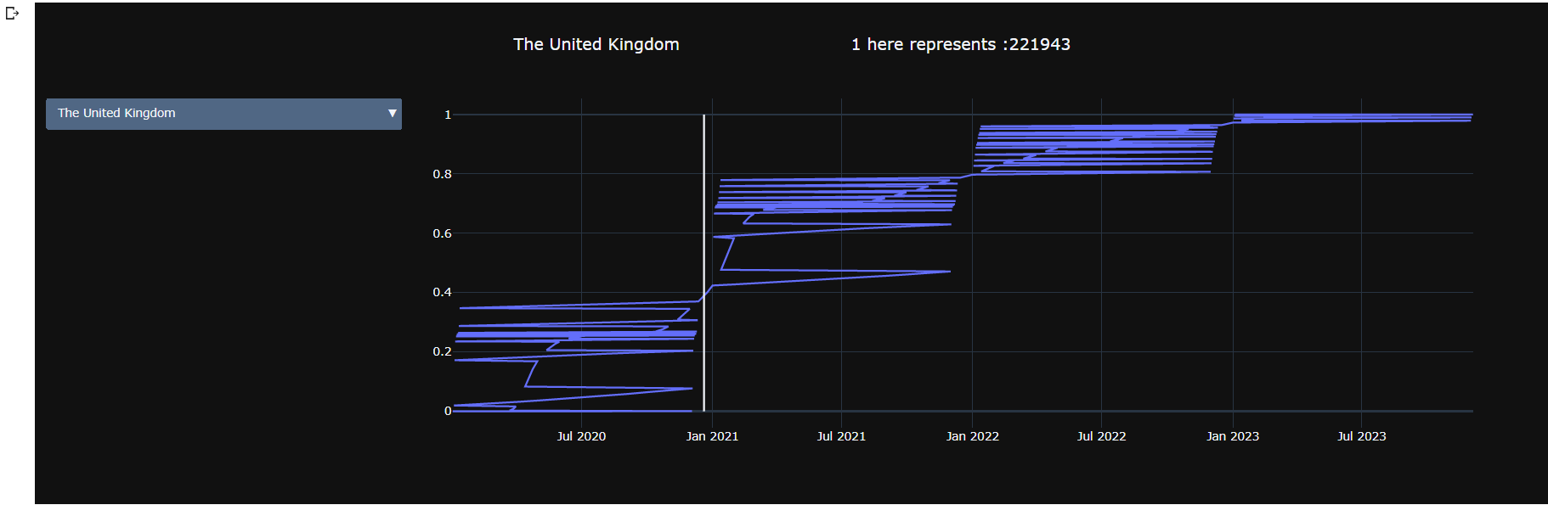

Overall COVID-19-related deaths in each nation are significant for visualization since they give an overview of the extent of the pandemic and its effects on various parts of the globe. Making decisions about public health interventions can be made more effectively by people, academics, and politicians when the data is visualized.

For instance, a visualisation can reveal that specific nations or regions have disproportionately greater death rates than others, suggesting that focused efforts are required there to stop the spread of the disease and stop more casualties.

**= = = = = = = = = = = = = = = = = = = = = = = = = = = = = = = = = = =**

**Visualisation 8:**

**What are the types of Vaccines used?**

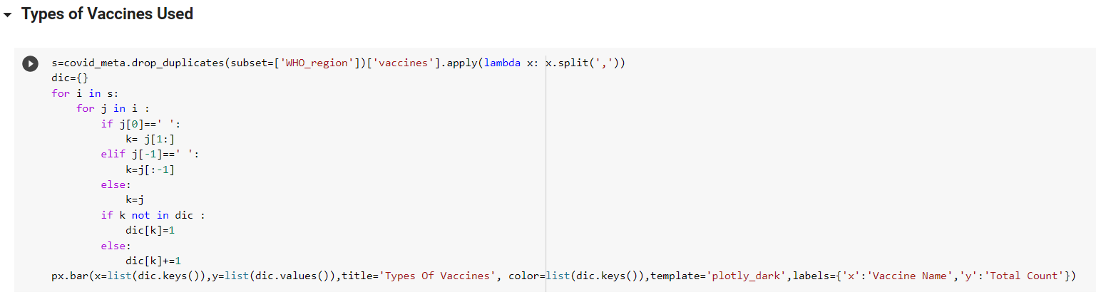

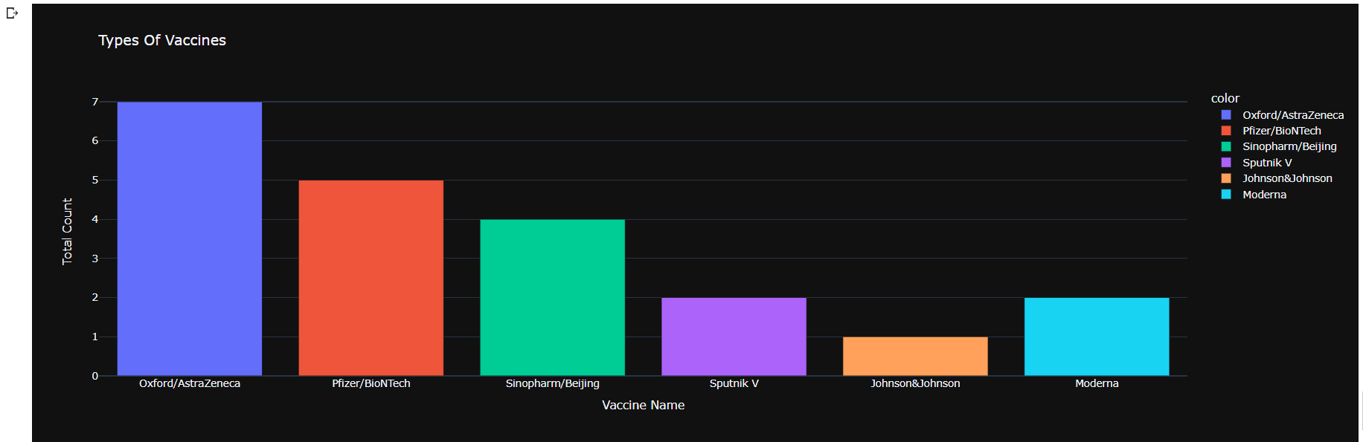

The use of COVID-19 medication is visualised as it is possible to monitor vaccination advancement and spot areas that might benefit from extra money or focused actions. It can also be used to help health professionals make sure that amounts are given out fairly and that priority populations get them as well as to help investigators assess the vaccines' effectiveness in stopping fatalities or serious illnesses as well as decreasing transfer.

**= = = = = = = = = = = = = = = = = = = = = = = = = = = = = = = = = = = =**

**Visualisation 9:**

**What is the Total Vaccinations Region-wise?**

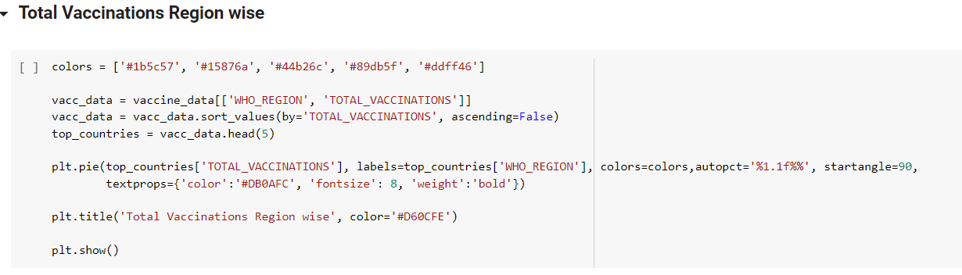

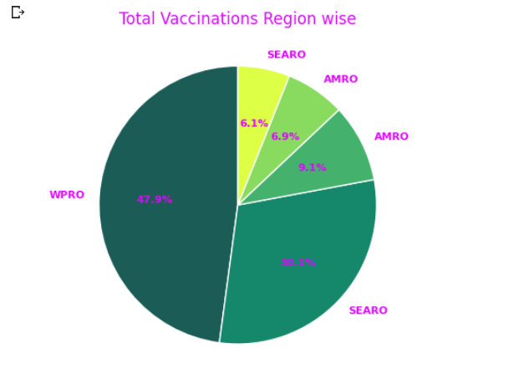

It is crucial to visualize the overall number of immunizations by area for a number of purposes. Tracking development to follow the development of vaccination campaigns around the globe. This data can be used to pinpoint areas with low vaccination rates, assign efforts to speed up the vaccination campaign, and pinpoint differences in vaccination rates among regions. Using this data, efforts can be directed towards areas with lower vaccination rates to make certain the vaccination program is fair and successful. To achieve a successful and fair worldwide vaccination campaign against COVID-19, this knowledge may assist direct the use of assets and influence making choices.

**= = = = = = = = = = = = = = = = = = = = = = = = = = = = = = = = = = = =**

***Task 2: TABLEAU VISUALISATION***

**Dashboard:**

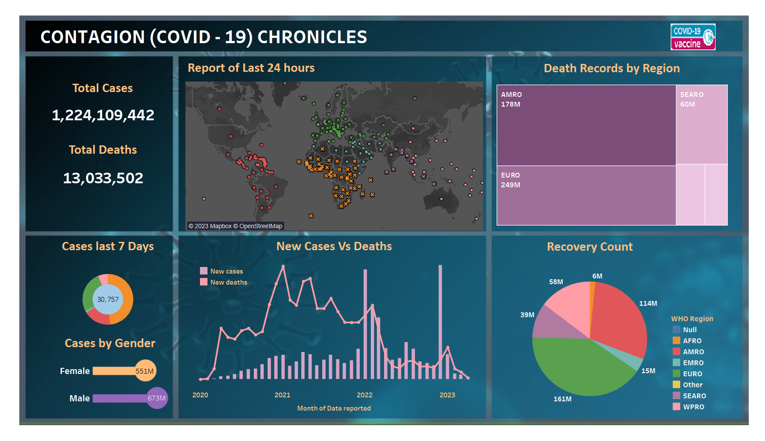

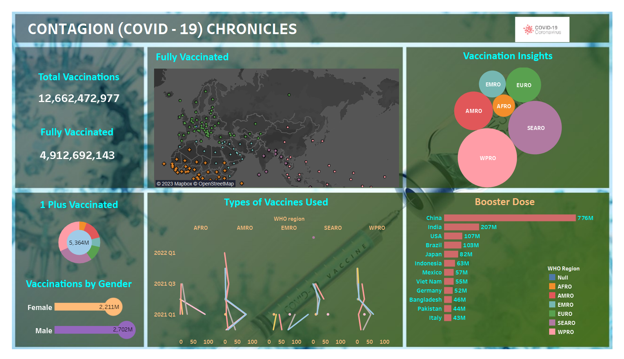

Country-level COVID-19 cases: A globe is used to create this visualization by coloring each nation according to the number of cases or fatalities. It can help us comprehend how the pandemic has affected various nations across the entire globe.

Death rates by region: For comparing the death rates for different ages and areas, a heat map is used to generate the visualisation. Understanding how death rates differ by age group and location can assist with choices and guide the targeting of treatments and expenditures.

The ensuing donut chart will show the average number of COVID-19 instances during the previous seven days by severity category, with each slice of the donut standing in for a particular severity level and its size reflecting the number of instances in that group. The total number of instances can be immediately understood using this form of visualisation, as well as any changes or trends in severity over time.

Then, using a pie chart with each category represented as a different slice of the pie, the recovery counts for every area can be seen. This strategy can assist in highlighting the seriousness of sickness and rates of healing for various geographic areas and in identifying any inequalities or trends that require attention.

The percentage of people who have received all recommended vaccines in relation to the total number of vaccinations for each country can be visualised using overall injections and the term "fully vaccinated." Additionally, it might be useful in identifying any differences in vaccination rates between nations including tracking advancements made in obtaining collective immunity.

Due to a number of variables, particularly social support, services for reproductive health, and maternity and child health programs, women may have better access to healthcare services, including immunisation. Increased vaccination rates among women may be the outcome of this. Women may believe they are more vulnerable to certain illnesses or consequences, issues from childbirth, and may therefore be more likely to seek immunisations.

A booster dose of vaccination is given to increase the period of safeguarding or to offer additional protection against disease. Booster doses are normally offered following the conclusion of the initial immunization sequence and may be administered months or even years later. Certain vaccines may cause a person's immunity to weaken over time, making them more susceptible to illness. Doses of boosters may aid in regaining resistance and extending security. So, Booster dose visualization is used to know the country-wise people took for immunisation.

Overall, Tableau Visualization is designed in a way it can give information on both the covid cases and vaccinations in two different tabs so that it’s easy to have a look at full covid case Insights.

Link to My Tableau Dashboard:

<https://public.tableau.com/app/profile/lashika.arunachalam/viz/FinalCovid19_16819807807400/VaccinationInsights?publish=yes>

**= = = = = = = = = = = = = = = = = = = = = = = = = = = = = = = = = = = =**

**REFERENCES**

1. Bandiera, O., Guiso, L., Prat, A., & Sadun, R. (2011). What do CEOs do? Florence: European University Institute.
2. Markham, S. E. (2010). Leadership, levels of analysis, and déjà vu: Modest proposals for taxonomy and cladistics coupled with replication and visualization. The Leadership Quarterly, 21(6), 1121–1143. doi: 10.1016/j.leaqua.2010.10.011
3. Shah, P., Mayer, R. E., & Hegarty, M. (1999). Graphs as Aids to Knowledge Construction: Signaling Techniques for Guiding the Process of Graph Comprehension. Journal of Educational Psychology, 91(4), 690–702. doi: 10.1037/0022-0663.91.4.690
4. Stone, M. (2018). Color for Visualization [Powerpoint Slides]. Retrieved from <https://courses.cs.washington.edu/courses/cse442/18au/lectures/CSE442-Color.pdf>
5. Sarkar, D. (2018). Practical Tableau: 100 tips, tutorials, and strategies from a Tableau Zen Master. O'Reilly Media.
6. Murray, S. (2017). Tableau your data!: Fast and easy visual analysis with Tableau Software. John Wiley & Sons.
7. Sleeper, J., & Jones, B. (2015). Tableau dashboard cookbook: Over 40 recipes on designing professional dashboards by implementing data visualization principles. Packt Publishing Ltd.